# **Ntokozo Mweli**

# **Student number: ST10119556**

# **Module: APDS 7311**

# **Lecturer: Mr. Isaac Leshaba**

# **8 November 2022**

# **POE**

# TABLE OF CONTENT

USER INTERFACES 3

ADDITIONAL SECURITY FEATURES 5

STARTING FRONTEND AND BACKEND 6

REFERENCES 7

# TABLE OF FIGURES

Figure 1 List of posts page 3

Figure 2 Add a post 4

Figure 3 Sign Up of the user 4

Figure 4 Login of the user 5

Figure 5 Additional security features 5

Figure 6 Use of brute on post requests of login and signup of the user 6

Figure 7 Starting frontend with angular 7

# USER INTERFACES

The user interface of the website has 4 pages. It is the list page, add post page, login page and signup page.

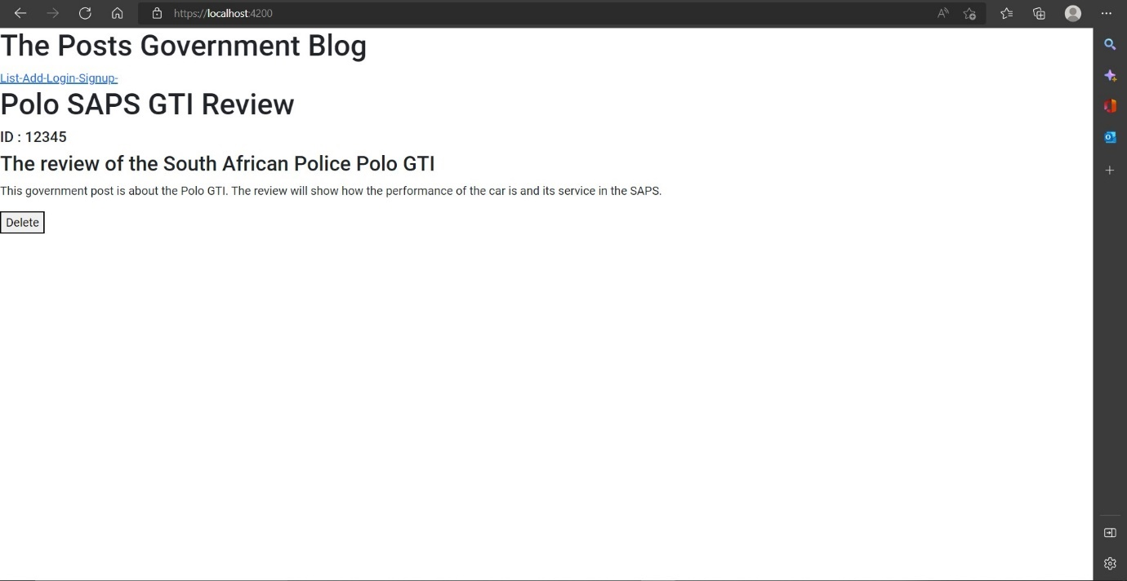

Figure List of posts page

The list of posts is shown in Figure 1 in that format (Digamber, 2022) (Bouchefra, 2019).

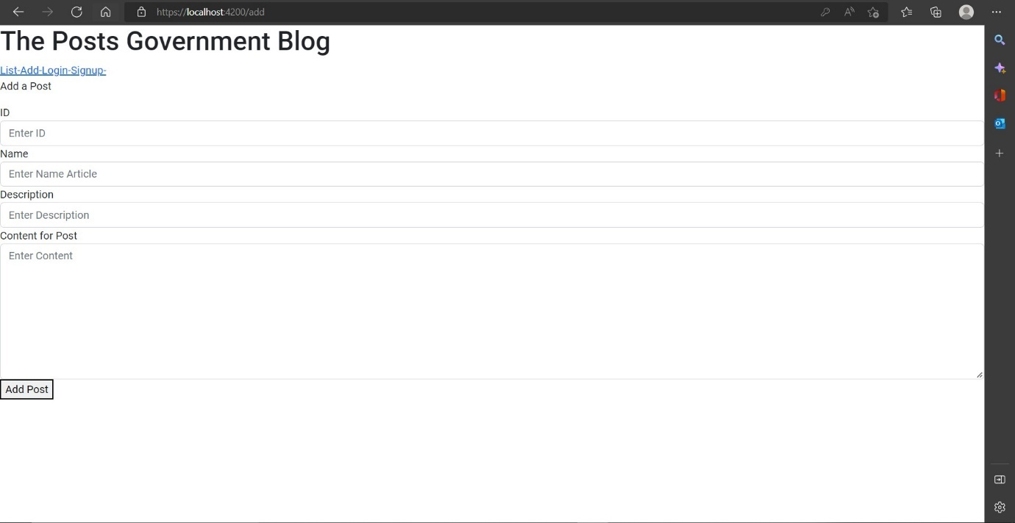

Figure Add a post

Figure 2 shows the adding of the post. The user can enter the ID, name, short description of the post and the content presenting the post (Asif, 2020). The user will be notified if the post has been added (Asif, 2020).

Figure Sign Up of the user

The user can signup using the username and password. The minimum length of username is 6 and password is 8 (Asif, 2020).

Figure Login of the user

The user can login using the username and password. The minimum length of username is 6 and password is 8. Login will provide the token required to add a post to the mongo database (user184994, 2018).

# ADDITIONAL SECURITY FEATURES

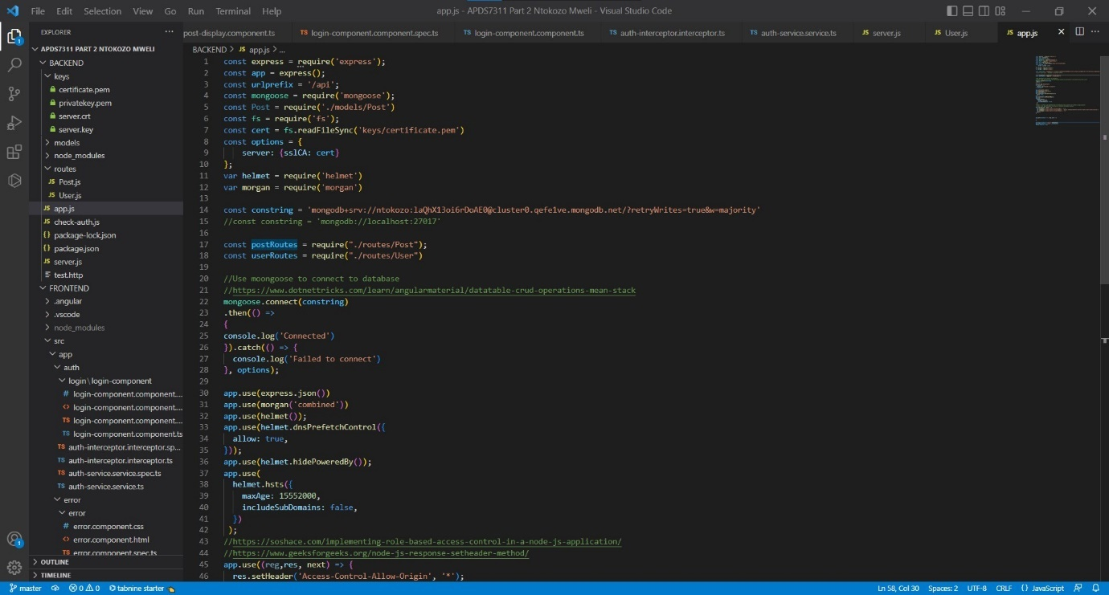

Figure Additional security features

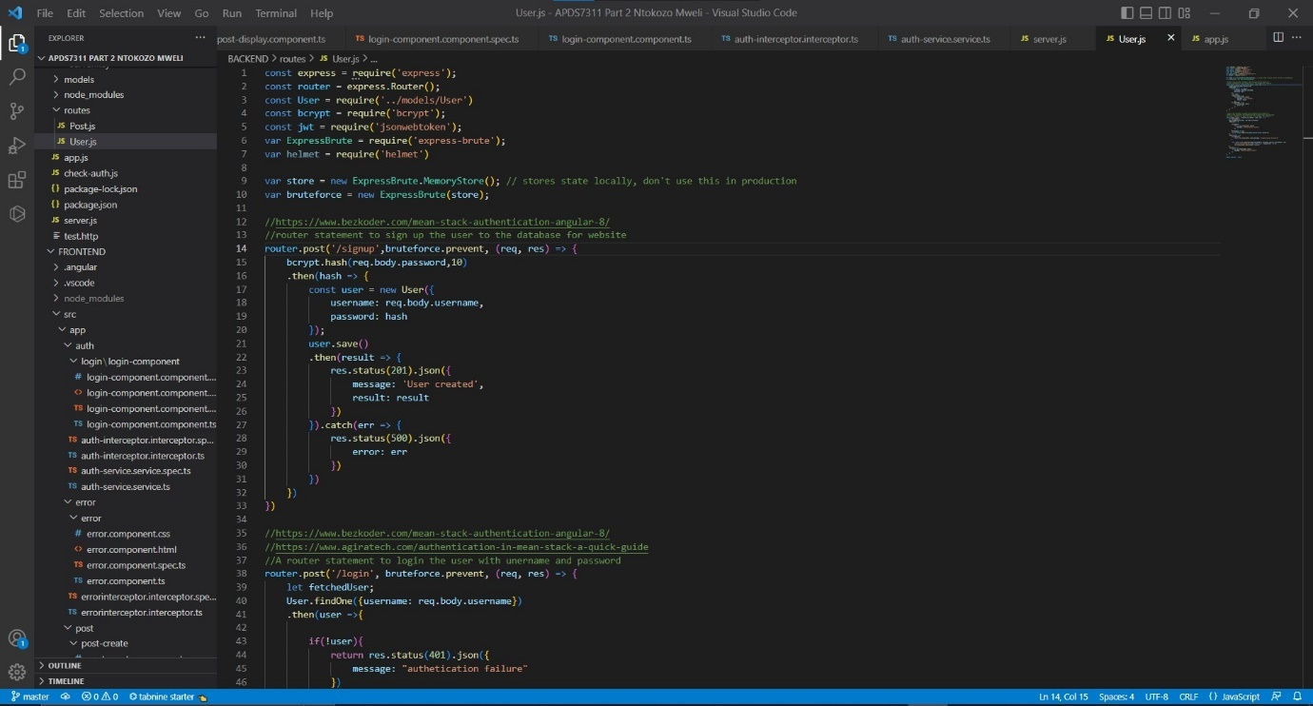

Figure Use of brute on post requests of login and signup of the user

Additional security features include use of brute, morgan and helmet. The brute seen in Figure 6 is to reduce the risk of brute force attack during login and signup of the user (npmjs, 2022). It is added as a parameter to help prevent brute force in the login and signup requests (npmjs, 2022).

In Figure 5 is the use of morgan and helmet. The helmet.js is designed to help secure Express applications with the setting of HTTP headers. It is a middleware. Morgan is also middleware but works with HTTP request level which is useful for logs with requests along with other information depending on configuration being made. Helmet used here is for the strict transport security, the x-powered by and x-DNS-Prefetch-Control methods (Dechalert, 2021). Morgan is the simple use of stating its use with combined letter (Dechalert, 2021).

# STARTING FRONTEND AND BACKEND

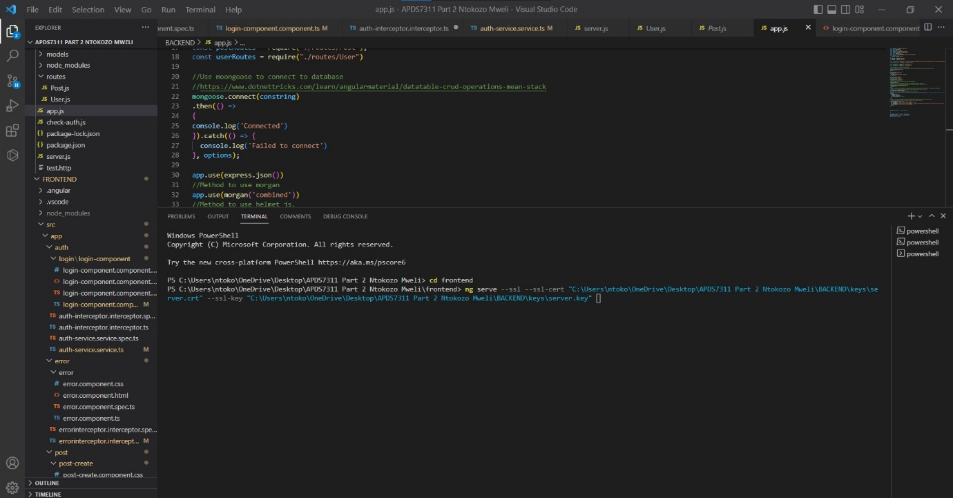

Figure Starting frontend with angular

To start the backend, the path needs to be “\APDS7311 Part 2 Ntokozo Mweli\backend and then type npm run dev. It will start running on the backend. To start the angular frontend, the path and statement need to be run like shown in Figure 7. However replace the paths of the key and certificate with path accordingly on the other pc (CodePosibility, 2020). To do this, right-click on the key and/or certificate and select copy path to copy the path (Vermeulen, 2018) (Adriano, 2021).

# REFERENCES

Adriano, H., 2021. *How To Serve Your Angular Application Over HTTPS Using ng serve,* 14 January 2021*.* [Online].   
Available at: https://betterprogramming.pub/how-to-serve-your-angular-application-over-https-using-ng-serve-240e2c2e0a5d  
[Accessed 16 October 2022].

Asif, M., 2020. *Registration Successful Message in HTML & CSS,* 28 June 2020*.* [Online].   
Available at: https://codeconvey.com/registration-successful-message-html/  
[Accessed 6 November 2022].

Bouchefra, A., 2019. *Styling An Angular Application With Bootstrap,* 19 February 2019*.* [Online].   
Available at: https://www.smashingmagazine.com/2019/02/angular-application-bootstrap/  
[Accessed 27 October 2022].

*How to use Angular CLI and self-signed SSL Certificate to serve over HTTPS in localhost. 2020.* YouTube video, added by CodePosibility.[Online].   
Available at: https://www.youtube.com/watch?v=OWjVXb7-mSU  
[Accessed 16 October 2022].

Dechalert, A., 2021. *What is Helmet.js & Why it is a Security Best Practice For Express.js,* 23 June 2021*.* [Online].   
Available at: https://www.securecoding.com/blog/using-helmetjs/  
[Accessed 1 November 2022].

Digamber, 2022. *Angular 14 MEAN Stack CRUD Tutorial Example,* 22 August 2022*.* [Online].   
Available at: https://www.positronx.io/mean-stack-tutorial-angular-crud-bootstrap/  
[Accessed 2 November 2022].

npmjs, 2022. *express-brute,* 2022*.* [Online].   
Available at: https://www.npmjs.com/package/express-brute  
[Accessed 30 October 2022].

user184994, 2018. *How to catch the successful request using httpClient interceptor?,* 18 November 2018*.* [Online].   
Available at: https://stackoverflow.com/questions/53361348/how-to-catch-the-successful-request-using-httpclient-interceptor  
[Accessed 6 November 2022].

Vermeulen, R., 2018. *Running Angular CLI over HTTPS with a Trusted Certificate,* 25 February 2018*.* [Online].   
Available at: https://medium.com/@rubenvermeulen/running-angular-cli-over-https-with-a-trusted-certificate-4a0d5f92747a  
[Accessed 18 October 2020].